**Modern Chinese photography 1910s-1980s**

Modern Chinese photography spans from the late 1910s to the 1980s, including the Republican era (1912-1949), the Communist Mao era (1949-1976) and the post-Mao reform era (1976-1989), producing different national imagery amid different socio-political conditions. A modern consciousness in Chinese photography emerged against the backdrop of foreign incursions and the local New Culture Movement from the mid-1910s, when photographers sought a new national aesthetic and visual modernity through the camera lens. In part influenced by traditional ink painting, these photographers sought to make fine art photography to produce imagery for the new republic. The Chinese Communist Party continued this search for national characteristics and imagery with a different approach after Mao Zedong’s Yan’an Talk in 1942. Photography, with its realistic quality, was used more as a propagandistic tool than an art form, promoting the Socialist dream and, especially during the Cultural Revolution (1966-1976). Breaking through the strictures of the Cultural Revolution after the announcement of economic reforms and ‘opening up’ in 1978, amateur photographers began to aim their lenses at everyday life and individual sentiment in a humanist way, amid a less ideologically controlled socio-political environment. Also, in the 1980s, with western philosophy imported and translated in China, photographers created a ‘New Wave’ modernist style of experimentation.

The New Culture Movement (1910s-1920s) was an Enlightenment-inspired movement initiated by a group of Western educated intellectuals based at Beijing University. They aimed to break through tradition and create a modern Chinese culture by borrowing so-called Western standards. Echoing this movement, from 1919-1921, a group of photography enthusiasts (known later as the “Light Society” 光社), comprised mostly of foreign educated academics from Beijing University, gathered to photograph the campus and hold photography exhibitions. In 1923, they formed the first amateur photography group in China named, “Research Association for Art Photography” (艺术写真研究会), and organized exhibitions and annual publications between 1924-1928. Key member and editor of the annuals, Liu Bannong (刘半农 1891-1934 ), published the earliest book on fine art photography in China, *Bannong on Photography* (*Bannong tanying 半农谈影*) in 1927.

Continuing this legacy, in the 1930s amateur photographic societies formed in Shanghai by groups of well-educated middle class people, largely involved in the publishing and commerce industry. The two most prominent societies, the China Photographic Study Society (中国摄影学社) and the Black and White Photographic Society (黑白影社), organized exhibitions and published catalogues and photographic magazines to showcase members’ works. Lang Jingshan (郎静山, 1892-1995), an influential member of the China Photographic Study Society, drew from traditional literati ink painting, producing composite photographs that earned international recognition in photography salons from the 1930s.

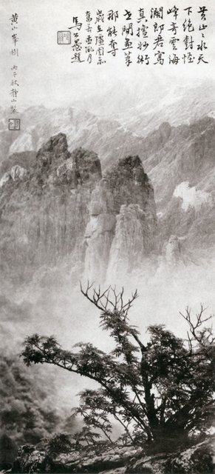

Lang Jingshan, Spring Trees and Majestic Peaks 春树奇峰, ca. 1934. Gelatin silver print from combined negatives. Sheying dashi Lang Jingshan [Lang Jingshan: Master Photographer] (Beijing: Zhongguo Sheying chuban she, 2003), plate 31. Taipei Lang Ching-shan i-shu wen-hua fa-chan hsueh-hui

In the late 1930s, photographers in Yan’an took up their cameras as ideological weapons, for the CCP. Sha Fei ( 沙飞1912-1950), an advocate of photography’s propagandistic potential, joined the Party in 1937 and immediately founded one of the first CCP pictorial magazines *Jinchaji Pictorial* (*Jinchaji huabao晋察冀画报*). Through this magazine and workshops, Sha trained many Communist photographers, using photography to educate the masses and build the CCP’s propaganda framework. In December 1956, the first official national photography organisation, the China Photographers Association, was established. After its establishment, photographic exchanges with the Soviet Union and the Eastern bloc increased, sharing Socialist ideas of nation building. In the first two decades of the PRC, photography was almost completely restricted to propagandistic news reporting. Photographing random items, people or scenes, without specific reference to socialist life, was not acceptable and even considered “bourgeois.”

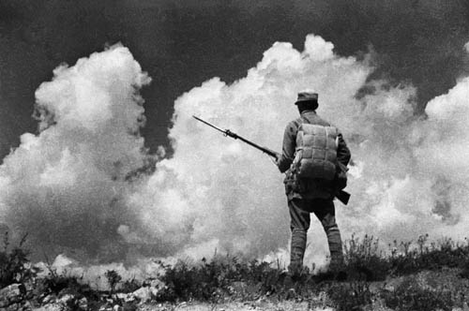

Sha Fei, Save the Nation, Save the Montherland, (保卫国土 保卫家乡), copyright www.shafei.cn

Ideological control over photography increased during the Cultural Revolution. Photographs were doctored to eulogise Mao Zedong as a heroic figure, and leaders that fell out of favour were often removed from historical photos. Following the aesthetic principles promoted by Mao’s wife Jiang Qing, photographs depicted people with rosy cheeks and glowing eyes, fixed on the beautiful future of Socialist life with Mao at the helm. However, the Cultural Revolution’s brutal realities were surreptitiously documented, notably by photojournalist for the *Heilongjiang Daily*, Li Zhensheng (李振盛 1940 **–**). Li hid shocking photographs of high-ranking cadres being violently, publicly humiliated under the floor of his home, until they were revealed in 1988.

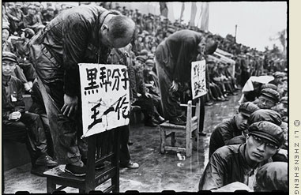

Li Zhensheng, 1966

<http://red-colornewssoldier.com/images/intro_pict.jpg>

Between the end of the Cultural Revolution in 1976 and the Tiananmen Massacre in 1989, photographic practice and amateur photographic groups burgeoned in an era of relative ideological freedom under Deng Xiaoping’s reforms. A group of individuals (later called the “April Fifth Photographers”) documented the “April Fifth Tiananmen Incident” in 1976 in the absence of official photojournalists. They challenged the Party-state’s photographic control, initiating a movement of photographic practice by the people. Making art not politics brought these photographers together to form the “April Photography Society” (四月影会), the first photography group of the post-Mao era. From 1979, the group held three annual exhibitions, presented under the single title *Nature, Society and Man*, all showing images of “everyday life”, celebrating quotidian beauty and private sentiments which challenged officially sanctioned visual culture.

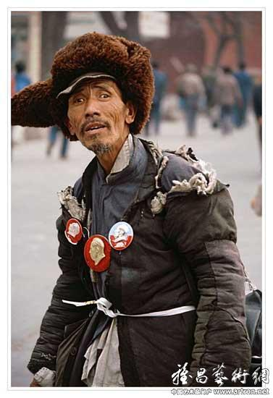

Li Xiaobin, The Petitioner 上访者, 1977

<http://img1.artron.net/artist/A0008250/brt00825000019.jpg>

Inspired by this society, other photography groups formed. Nearly overlapping with the “85 New Wave” (85新潮) movement in the visual arts, these groups initiated the photographic “New Wave” in 1980s China, with different approaches. Renren Photo Society, influenced by Hong Kong photography, pursued a salon aesthetic. Shaanxi Group and North River Alliance aimed their lens at rural everyday life and urban reality respectively. Five Ones and Fission Groups, influenced by the influx of translated Western philosophy and modern art, experimented with a formal modernist approaches. The Modern Photography Salon, with strong support from the State, promoted authentic news photography. This “New Wave” photography of the 1980s nurtured the development of trends that would become the better-known contemporary Chinese photography from the 1990s.

**References and further reading**

Jiang, Q., et al. (1998) *Chinese photography history 1937-1949* (*Zhongguo sheying shi, 1937-1949*), Beijing: Zhongguo sheying chubanshe.

Roberts, C. (2012) *Photography and China,* London: Reaktion Books.

Su, Z., (et al. eds.) (2009) *Introduction to the history of Chinese history* (*Zhongguo Sheying Shilue*), Beijing: Zhongguo wenlian chubanshe.

Tong, S. (et al. eds.) (1996) *Contemporary Chinese photographic art history 1949-1989* (*Dangdai zhongguo sheying yishushi 1949-1989*), Beijing: Zhongguo sheying chubanshe.